**Figure 1: A) Selective angiogram shows a high-grade stenosis of 80% in the left internal carotid artery. B) Selective angiogram after stent deployment in the left internal carotid artery.**

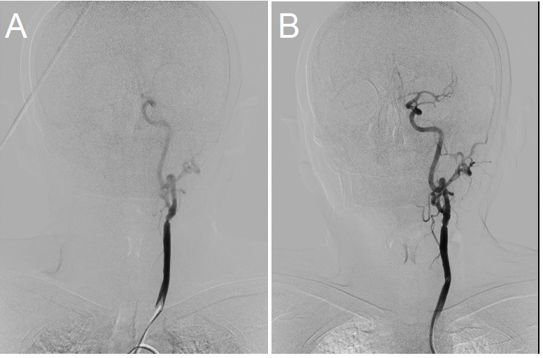

**Figure 2: A) Selective angiogram shows a high-grade stenosis of 80% in the right internal carotid artery. B) Selective angiogram after stent deployment in the right internal carotid artery. Arrows show the stent deployed into the right carotid artery in the same procedure.**

